Modern Stack Architecture Flow
TrackAllLoanMaintenanceLegacy
────────────────────────────
Loan Maintenance Modernization Document Set

Table of Contents
1.2 Target State — System Context
4. Service Boundary Map
5. Integration Map
6. Architecture Decision Prompts
6.1 Coupling analysis
6.2 Pattern fitness table
6.3 Framing
7. Legacy → Modern Mapping
Open Items / Ambiguities
Traceability Summary / Cross-Reference

Document Governance Note
Grounding labels covered in this publication set: [SG], [SG-influenced], [inferred], [placeholder]. Review Priority badges are styled as Priority or Standard where rule-review columns appear.

Modern Stack Architecture Flow

1.2 Target State — System Context
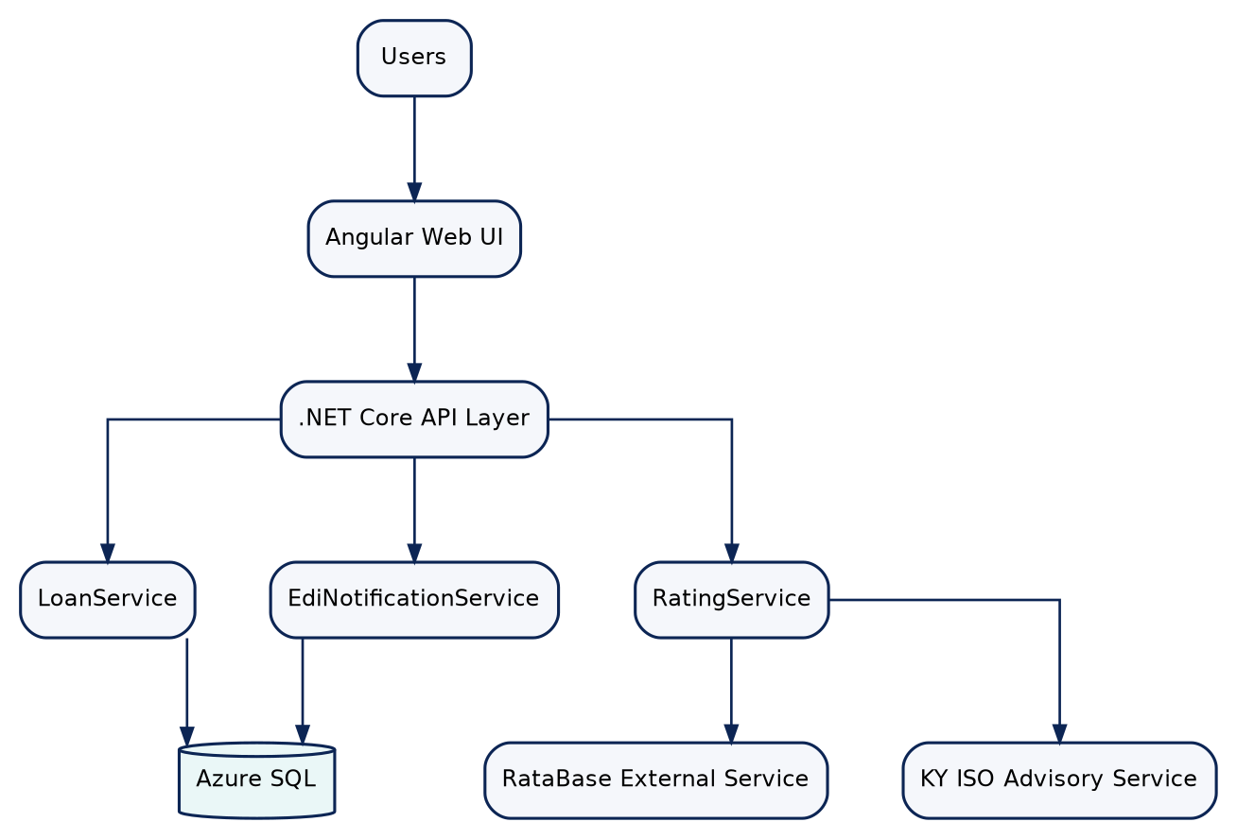
Mermaid diagram rendered from source (1)

4. Service Boundary Map
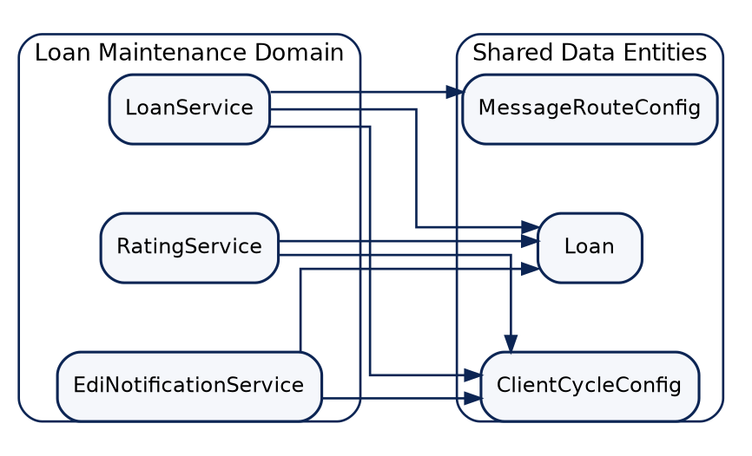
Mermaid diagram rendered from source (2)

5. Integration Map
Integration Point | Protocol | Direction | Legacy System | Modern Target | Evidence
Loan search orchestration | Tandem SQL/MP path via TKA900 | Bidirectional | TKA900 + LSS_LOAN_T/LSS_CYCLE_STEP_T | LoanService + Azure SQL query layer | screen_action_api_estimation.md; service_decomposition.md
Add loan transaction | Tandem SQL/MP path via TKA901 | Bidirectional | TKA901 + LSS_LOAN_T | LoanService POST /api/loans + Azure SQL insert | screen_action_api_estimation.md
Modify loan transaction | Tandem SQL/MP path via TKA902 | Bidirectional | TKA902 + LSS_LOAN_T | LoanService PUT /api/loans/{loanNum} + read-before-write | screen_action_api_estimation.md
Rating quote call | External service call | Outbound | RataBase | RatingService external adapter | service_decomposition.md
KY advisory pre-call | Tandem program call via KY_ISO_QUERY | Outbound | AIP930 | RatingService KY advisory adapter | service_decomposition.md
14E notification dispatch | Tandem dispatch via TKA920 | Outbound | TKA920 | EdiNotificationService dispatch adapter | service_decomposition.md

6. Architecture Decision Prompts

6.1 Coupling analysis
The analysis suggests LoanService and EdiNotificationService share loan/cycle data dependencies, while RatingService is integration-coupled to external rating and KY advisory lookups.

6.2 Pattern fitness table
Pattern | When it fits | Evidence from this analysis
modular monolith | Tight shared data and limited service count | Shared Loan/Cycle entities across three candidate services
microservices | Distinct ownership and independent scaling needs | Distinct integration concerns for rating and EDI paths
strangler fig | Progressive replacement of Tandem call paths | Clear mnemonic-to-API mapping per operation
CQRS | Heavy read/write divergence | Search/read paths differ from add/modify command rules
event-driven | Asynchronous notification scenarios | EDI dispatch currently synchronous; potential future async prompt

6.3 Framing
The analysis suggests preserving read-before-write semantics and explicit suppression outcomes during modernization, regardless of final deployment topology.

7. Legacy → Modern Mapping
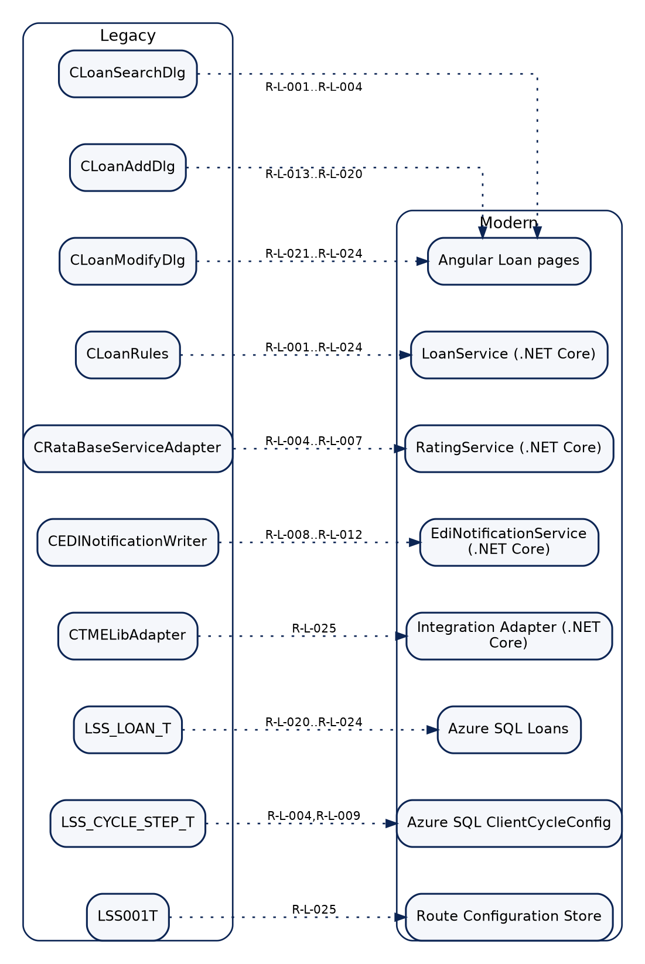
Mermaid diagram rendered from source (3)
Diagram suggestion callout:
- For the Legacy -> Modern mapping, use side-by-side diagram rendering with clear dotted-equivalence arrows retained.
---

Open Items / Ambiguities
Unresolved items requiring SME or implementation-team validation are listed below.
ID | Open question
A-001 | Add/Modify rc templates and concrete control definitions are missing from current resource files.
A-002 | Three Loan Search control IDs are referenced in code but absent in current rc/resource definitions.
A-003 | Confirm whether "loan must exist before modification" should be promoted to a standalone rule card.
A-004 | Confirm whether selected-row precondition for opening Modify is documented as a formal business rule.
A-005 | Confirm add-handler delegation evidence treatment for rule-card references.
A-006 | Confirm modify-handler delegation evidence treatment for rule-card references.

Traceability Summary / Cross-Reference
Rule ID | Functional Area | Review Priority | Candidate API / Service | Blueprint Spec
R-L-001 | Loan Search Input Validation | Standard | POST /api/loans/search (LoanService) | UI-001 + SVC-001
R-L-002 | Loan Search Input Validation | Standard | POST /api/loans/search (LoanService) | UI-001 + SVC-001
R-L-003 | Loan Search Input Validation | Standard | POST /api/loans/search (LoanService) | UI-001 + SVC-001
R-L-004 | Premium Rating | Standard | POST /api/quotes/rating (RatingService) | UI-001 + SVC-002
R-L-005 | Premium Rating | Standard | POST /api/quotes/rating (RatingService) | SVC-002
R-L-006 | Premium Rating | Standard | POST /api/quotes/rating (RatingService) | SVC-002
R-L-007 | Premium Rating | Standard | POST /api/quotes/rating (RatingService) | SVC-002
R-L-008 | EDI Notification | Standard | POST /api/edi/notifications/14e (EdiNotificationService) | SVC-003
R-L-009 | EDI Notification | Standard | POST /api/edi/notifications/14e (EdiNotificationService) | SVC-003
R-L-010 | EDI Notification | Standard | POST /api/edi/notifications/14e (EdiNotificationService) | SVC-003
R-L-011 | EDI Notification | Standard | POST /api/edi/notifications/14e (EdiNotificationService) | SVC-003
R-L-012 | Audit Trail | Standard | POST /api/edi/notifications/14e (EdiNotificationService) | SVC-003 + DB-AUDIT
R-L-013 | Add Loan Validation | Standard | POST /api/loans (LoanService) | UI-002 + SVC-001
R-L-014 | Add Loan Validation | Standard | POST /api/loans (LoanService) | UI-002 + SVC-001
R-L-015 | Add Loan Validation | Standard | POST /api/loans (LoanService) | UI-002 + SVC-001
R-L-016 | Add Loan Validation | Standard | POST /api/loans (LoanService) | UI-002 + SVC-001
R-L-017 | Add Loan Validation | Standard | POST /api/loans (LoanService) | UI-002 + SVC-001
R-L-018 | Add Loan Validation | Standard | POST /api/loans (LoanService) | UI-002 + SVC-001
R-L-019 | Add Loan Validation | Standard | POST /api/loans (LoanService) | UI-002 + SVC-001
R-L-020 | Add Loan Validation | Standard | POST /api/loans (LoanService) | SVC-001 + DB-001
R-L-021 | Modify Loan Validation | Standard | PUT /api/loans/{loanNum} (LoanService) | UI-003 + SVC-001
R-L-022 | Modify Loan Validation | Standard | PUT /api/loans/{loanNum} (LoanService) | UI-003 + SVC-001
R-L-023 | Modify Loan Validation | Standard | PUT /api/loans/{loanNum} (LoanService) | UI-003 + SVC-001
R-L-024 | Modify Loan Validation | Standard | PUT /api/loans/{loanNum} (LoanService) | UI-003 + SVC-001
R-L-025 | Integration Gateway | Standard | Internal TandemGatewayClient | SVC-001 + SVC-003

